Data Visualization – CSE3020

LAB 1 – Demonstrating GGPlot in R Lab

Name: Ayush Sharma

Reg. No: 15BCE1335

Faculty: Dr. Priyadarshini J

1. Use GGPLOT on the following data:  
   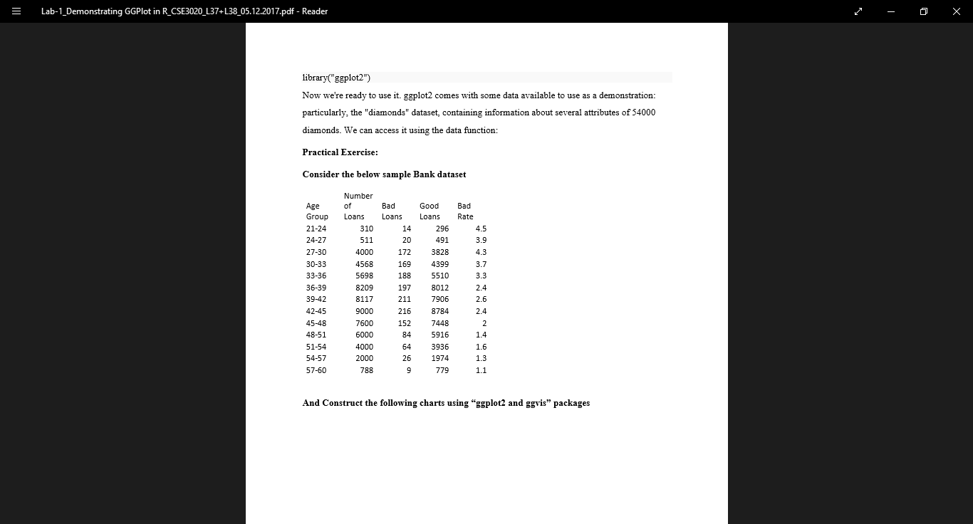

Code:

library(ggplot2)

r=read.csv("F:/STUDY MATERIALS/6th sem/data visualization/lab1-2/Bank.csv")

attach(r);

ggplot(r,aes(x=Age.Groups,y=Number.Of.Loans))+ geom_bar(stat = "identity")+ coord_cartesian(ylim = c(0,8000))

par(new=T)

plot(Bad.Rate,type="l",col="Orange",lwd=2, ylab="",xaxt = "n",yaxt= "n",bty="n")

legend("topright",legend=c("Bad Rate"),

       col=c("orange"), lty=1:1, cex=.7)

Screenshot:

